Adding Crendentials in HCS

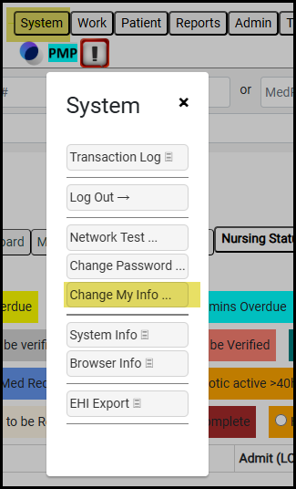
- Choose System -> Change My Info
- Update your Credentials in the Degree blank (Highlighted below)
- Click Save
